**The Three-Layer Architecture**

This pattern is also called Three-Tier architecture and the Mud-to-Structure pattern.

Here is the basic structure:

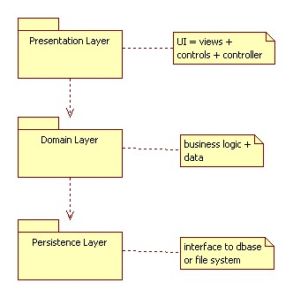

Carefully note that the dependencies are one-way. This implies that the persistence layer can be reused with different domain layers and that the domain layer can be reused with different presentation layers.

The term "tiers" is usually used when the layers are running on different computers. In this case we might think the presentation layer is a thin client, the domain layer is an application server, and the persistence layer is a database server.

We can generalize this pattern to the N-tier architecture by dividing the presentation and domain layers into finer layers.

This architecture was made popular by UNIX "onion" architecture and the ISO OSI reference architecture.

The most popular example is what I call the 3.5 tier architecture in which a web server does some of the work of the presentation and domain layers.